Brian Dones

April 13, 2015

**Database Management: Lab 8 – Normalization 2**

**E/R Diagram:**

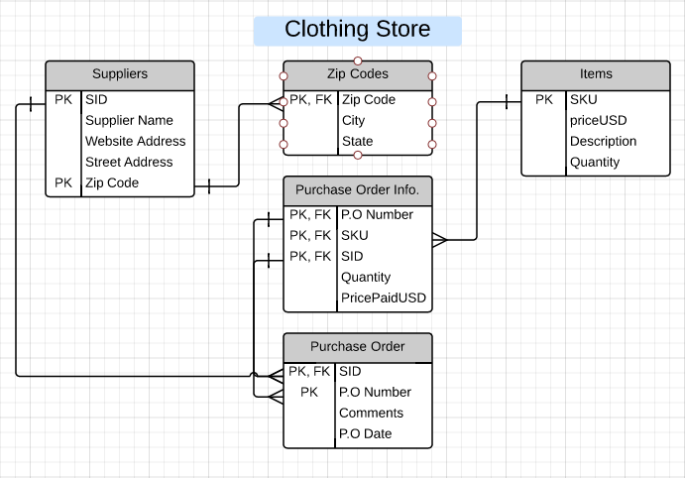

Functional Dependencies:

Suppliers Table - SID, Zip Code → Supplier Name, Website Address, Street Address

Zip Codes Table - Zip Code → City, State

Items Table - SKU → priceUSD, Description, Quantity

Purchase Order Table - SID, P.O Number → Comments, P.O Date

Purchase Order Info. Table - P.O Number, SKU, SID → Quantity, PricePaidUSD